# DATABASE SYSTEM PRACTICUM REPORT

# MODULE 8

**AGGREGASI**



**CREATED BY :**

**KURNIAWAN BAGASKARA**

**L200214253**

# INFORMATICS STUDY PROGRAM

**FACULTY OF COMMUNICATION AND INFORMATION SCIENCE MUHAMMADIYAH SURAKARTA UNIVERSITY**

Task.

1.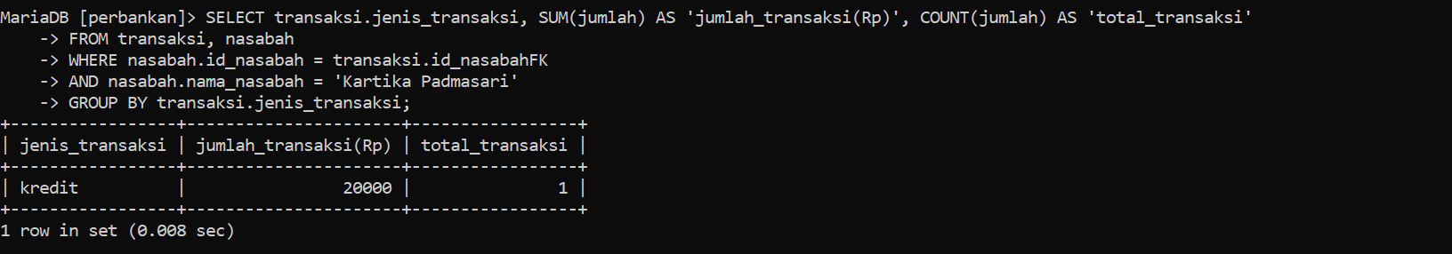

2.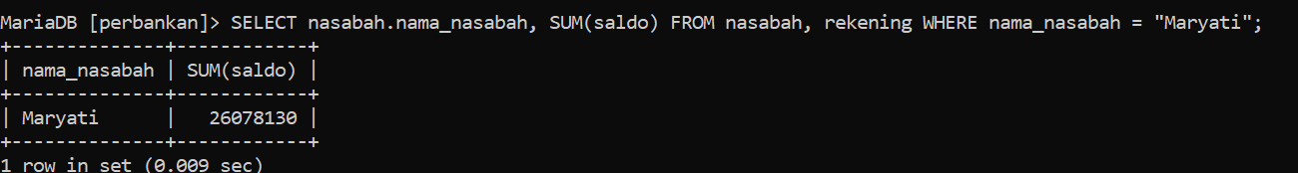

3.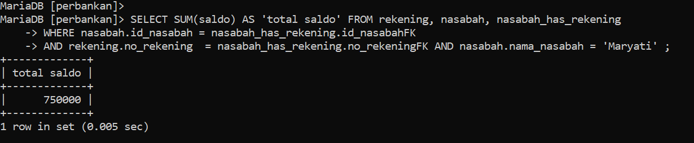

4.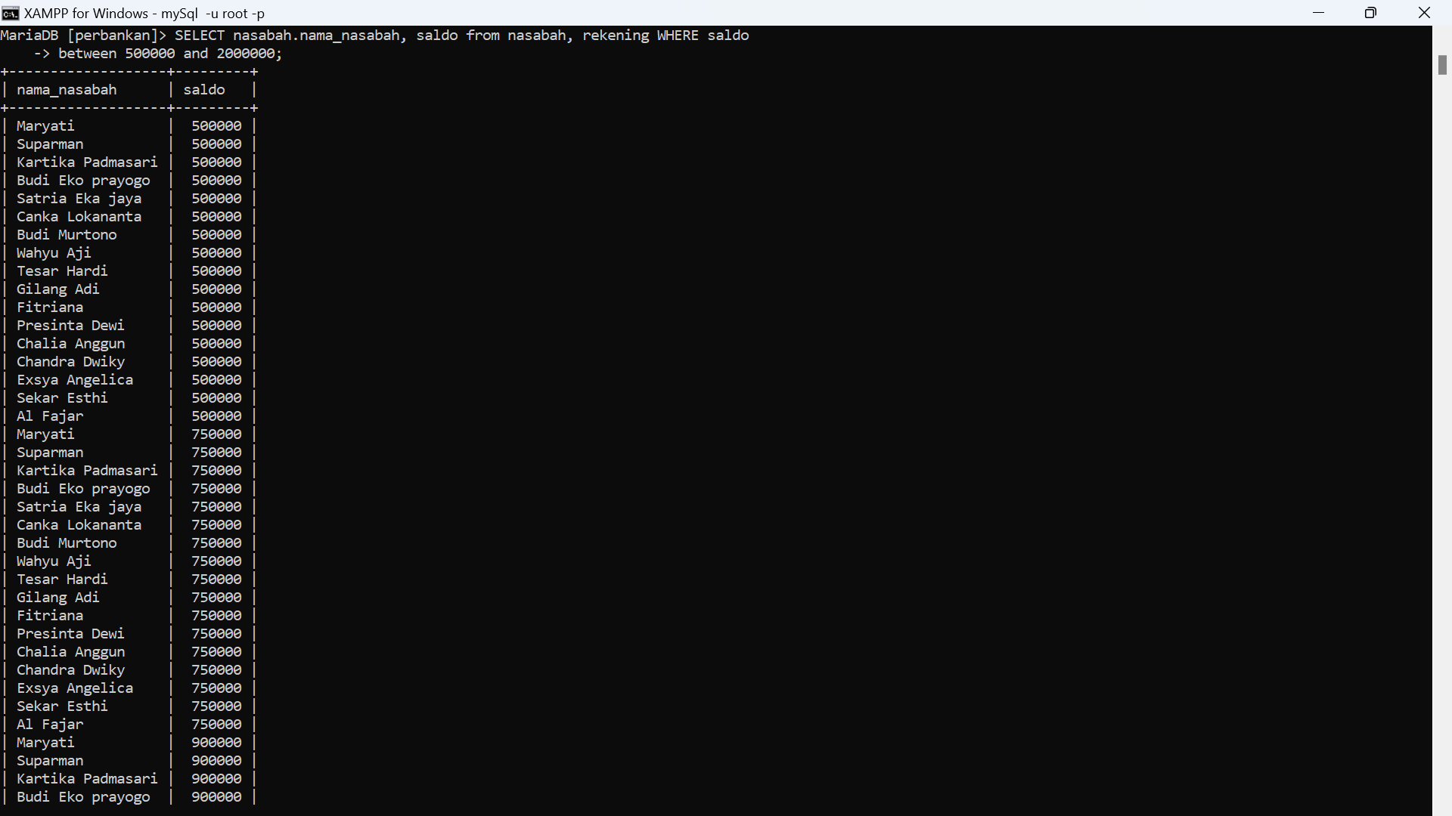

5.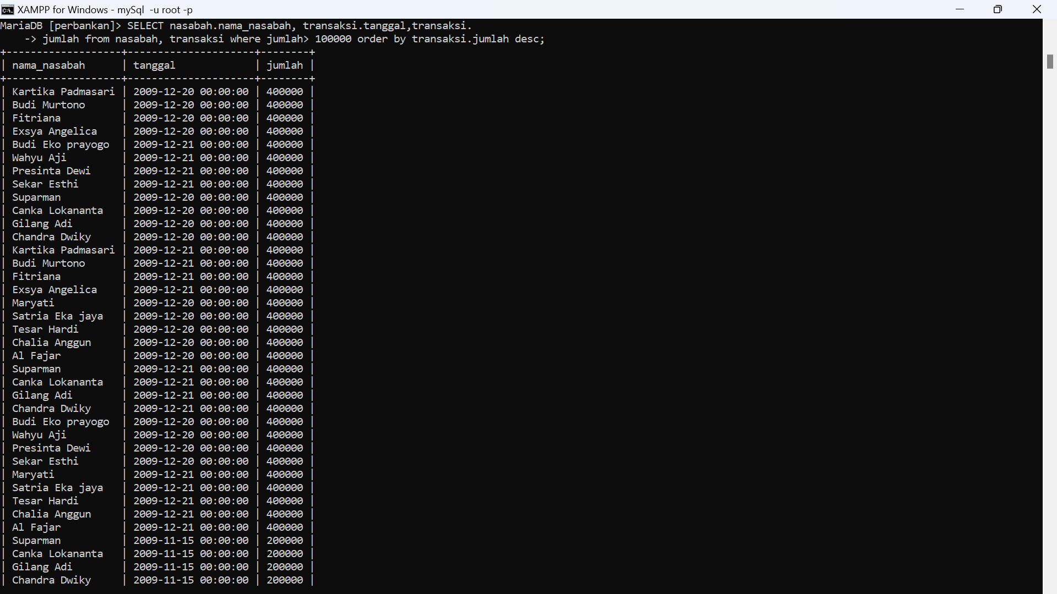

* Show transaction number and type of transaction on '2009-11-19'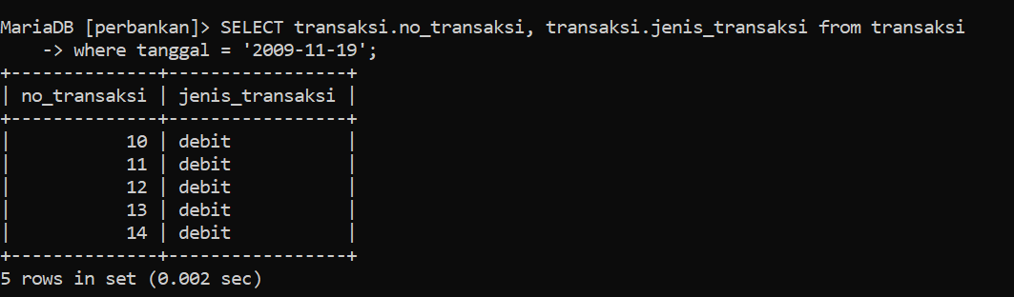
* Display the customer's name and the type of transaction where the type of transaction is debit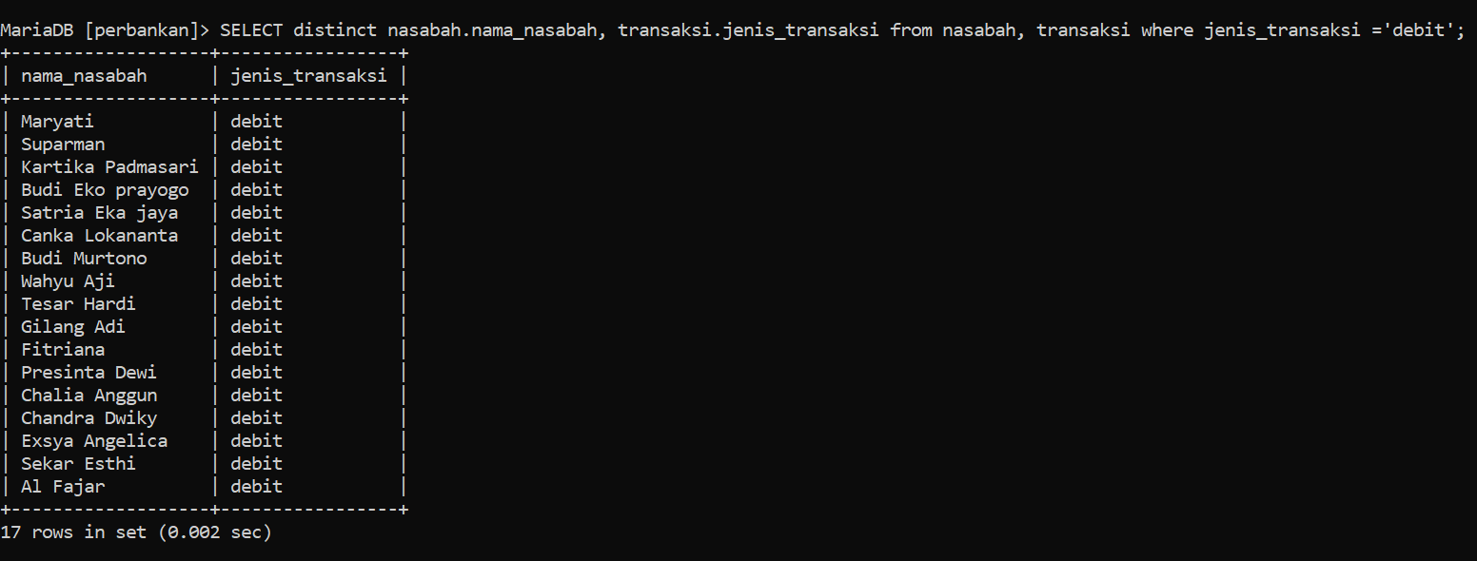
* Display the customer's name and type of transaction where the customer's name is Suparman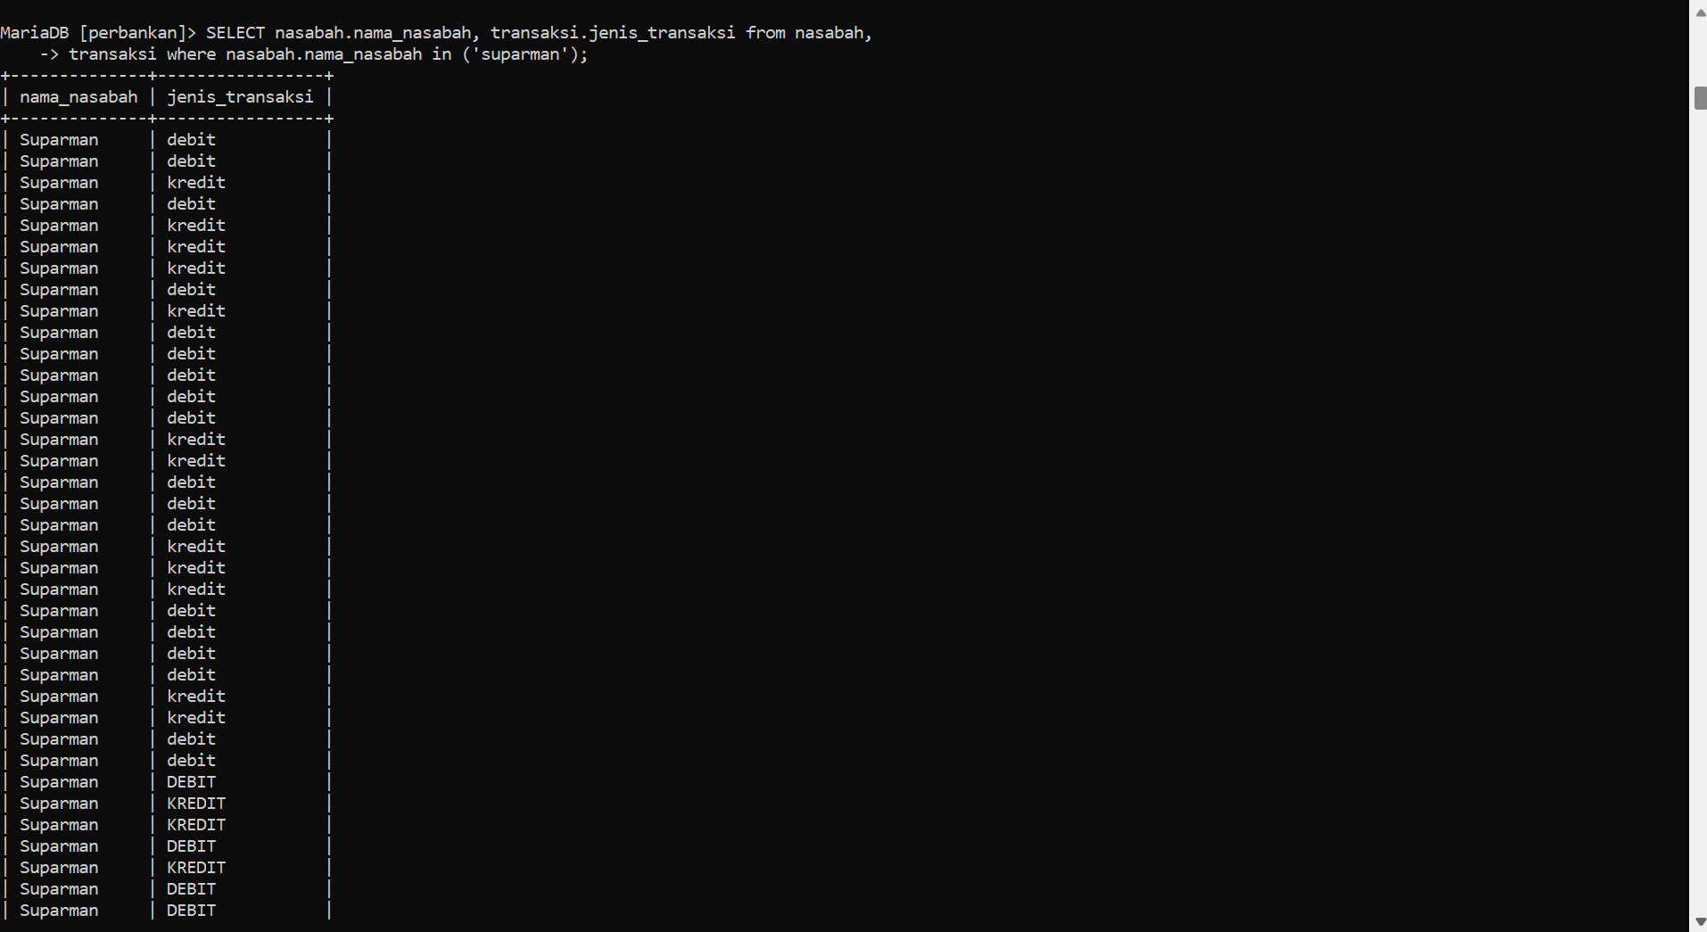
* Display the total balance owned by Suparman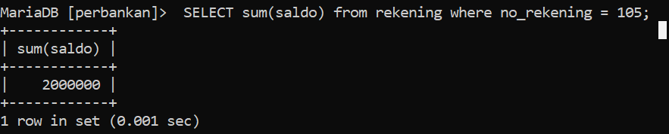
* Display the total number of transactions made by customers with customer id is 3